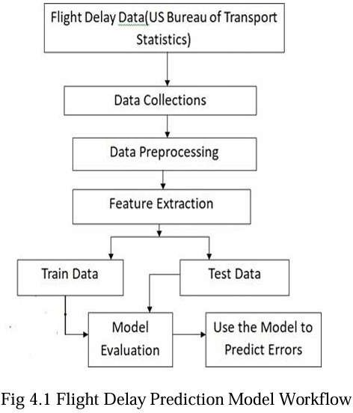

Fig 4.1 Flight Delay Prediction Model Work Flow

Use the Model to predict Errors

Data Preprocessing

Feature Extraction

Data Collections

Flight Delay Data (US Bureau of Transport Statistics)

Model Evaluation

Test Data

Train Data